CSE221 DIGITAL LOGIC FUNDAMENTALS
QUIZ – 2

- Convert the following Boolean expression into standard SOP and standard POS forms:
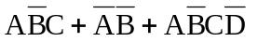

- Convert the decimal number 2,25 x 10¹ to a single-precision floating-point binary number.

